Fair Work First Statement and Declaration
Statement:
Royal British Legion Scotland Club (Thurso) Ltd is committed to advancing the Scottish Government Fair Work First Policy and the criteria as set out within the Fair Work First guidance document. We confirm that we pay our staff the Real Living Wage. We make every effort to ensure that our suppliers/contractors are offered the same Real Living Wage rate when procuring goods or services. We also confirm that we offer our staff and/or volunteers an Effective Workers Voice channel within the workplace.
We employ 10 staff and have 20 regular volunteers from our club membership of ~600 members.
Specifically:
- We have appropriate channels for effective voice from the workforce and/or volunteers;
- Line management – all employees have nominated line management. This is a formal and informal means of communications on a daily basis.
- Multiple staff and volunteer forums and discussions take place on a daily basis between staff and the volunteer Management Committee.
- The Club Chair is supported by a Management Committee who also have responsibilities that cross cut line management dependent upon the subject material and build a team relationship.
- Formal monthly Club Management Committee meetings take place that include the Bar Manager and Events Coordinator to discuss the key major topics of business performance and staff/employment issues.

The following points satisfy the self-declaration requirements for compliance with the effective voice criteria. If the answer to question 1a is no, further evidence of compliance will be required. Question 1b is only applicable where the organisation employs more than 21 staff. If the answer is no, further evidence of compliance will be required. Please confirm the following:

(1a) Royal British Legion Scotland Club (Thurso) Ltd will provide effective one to one line management for any employee or volunteer ensuring regular open and two-way dialogue; that this exists separately to performance management processes; and that worker/manager working relationships are effective.
Yes ☒ No ☐

(1b) Royal British Legion Scotland Club (Thurso) Ltd will ensure that as part of their induction, employees will be made aware of their right to join a union of their choice and will take a pro-union membership attitude.
Yes ☐ No ☒ NA ☐ Note: Although this is not part of their induction, the Club is open to employees joining a union if they wish.

- We actively invest in workforce and/or volunteer development;
- All staff and volunteers are appropriately trained for bar work, emergencies, Health and Safety, security (and will be safeguarding)
- Several members of staff have been trained and now hold alcohol licenses.

- We are committed to no inappropriate use of zero hours contracts;
- 3 employees are contracted for set hours.
- 7 are on casual/zero hours contracts that are appropriate for employment in hospitality where the footfall is completely unpredictable.

- We take action to tackle the gender pay gap and create a more diverse and inclusive workplace;
- All pay is determined by the post, qualifications and experience only.
- All recruitment is conducted by the requirements of the Club and post vs the ability of the candidate only.

- We are fully committed to paying the Real Living Wage to our employees. This is reviewed annually. Also, we would not knowingly procure supplies from any company that does not appropriately rewards its employees. We will, however, always attempt to ensure any contractors that conduct work in the Club are paid the real living wage.

This statement has been agreed by both the employer and a suitable workforce representative for our employees and/or volunteers:
Signature (for the employer): | 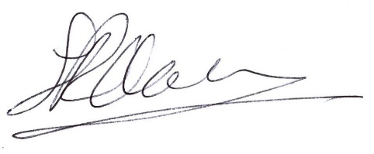
Print name: | Simon Middlemas
Position within organisation: | Club Chair
Date: | 21 August 2026

Signature (as workforce representative): | 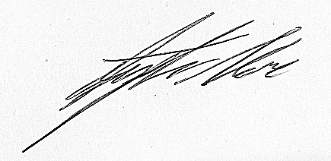
Print name: | Stephen Ness
Position within organisation: | Bar Manager
Date: | 21 August 2026

